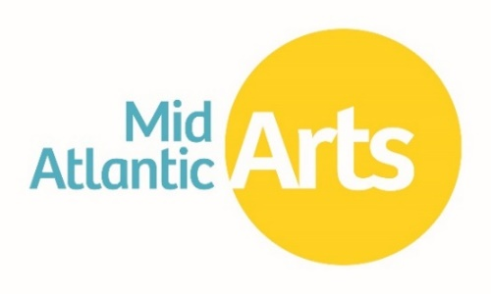
Individual Artist Fellowships
Work Sample Preparation Guide

This guide is intended to assist applicants with the compatibility of their existing work sample files and make informed decisions about work sample selection and submission. Mid Atlantic Arts is not able to assist with the recording or editing of the work sample content.

CONTENTS
GENERAL REQUIREMENTS 1
What are the technical requirements for work sample files? 1
How will the work sample quality impact the review of my application? 2
How do I determine the file type of my work sample? 2
My work sample is not the correct file type. How do I convert the file? 2
How do I determine the size of my file? 2
FILE NAMES 3
How should I name my files? 4
My file name contains identifying information. How do I rename a file? 4
What is the difference between the title and the file name? 4
IMAGE FILES & RESIZING 4
What is the image size limit? 4
My image files are too large and I need to make them smaller. How do I reduce the file size? 4
What are the pixel dimension requirements? 4
What DPI should I use? 4
Do I need to put a mat behind my images? 4
How can I make sure my images will look correct for the panelists? 5
Is it a problem if my images are small? 5
I notice that the rules & instructions say I can’t have a signature in the image but I sign all my works. What should I do? 5
Can Mid Atlantic Arts help me remove the signatures? 6
Is it OK to use a composite image? 6
The rules & instructions specify that I should not submit more than six examples of my work. What if a single work contains multiple components? 7
VIDEO FILES 8
What are the file properties and how can I see if my files contain identifying information? 9
My audio or video file includes identifying information in the file properties. How do I remove it? 10
My file is too big. Can Mid Atlantic Arts help me compress or reduce the size of my file? 10
PDF FILES 10
How do I convert a file to PDF? 11

GENERAL REQUIREMENTS

What are the technical requirements for work sample files?
Although all work samples submitted via https://midatlanticarts.smartsimple.com must meet certain basic criteria, it is very important that applicants check the current program rules & instructions to ensure they are following the correct work sample technical requirements.

Image Files must conform to the following specifications:
- Accepted file types: .jpeg, .jpg, .png, .bmp
- File size limit: 50 MB maximum per image

Literary Manuscripts must conform to the following specifications:
- File type: .pdf only
- All pages of the manuscript must be compiled into a single .PDF document.
- The document and file name must not contain the applicant’s name or other identifying information.

Video Files must conform to the following specifications:
- Accepted file types: .mp4, .mov
- Work samples must be stripped of any identifying or biographical information saved in the file properties.
- The video file name must not contain the applicant’s name or other identifying information.
- File size and time limits vary by category. Please refer to the Application Requirements by Category section below for additional information.

Audio Files must conform to the following specifications:
- Accepted file types: .mp3
- Work samples must be stripped of any identifying or biographical information saved in the file properties.
- The audio file name must not contain the applicant’s name or other identifying information.
- File size and time limits vary by category. Please refer to the Application Requirements by Category section below for additional information.

How will the work sample quality impact the review of my application?
It is always recommended that applicants submit the best work sample quality possible within the required size and time limitations.

All panelists are provided with a copy of the program rules & instructions and are familiar with the technical requirements for the work samples they are reviewing. Accordingly, they are aware that applicants may need to reduce the size of the files they are submitting. In most cases, minimal loss of image/video/audio quality due to resizing or compression will have no impact on review since the panelists are asked to focus on the work itself rather than the quality of the documentation. However, work samples should always be easy for the panelists to view, hear, and decipher. If panelists are not able to fully determine the artistic excellence of the work sample due to extremely poor quality recordings or images, this may lower the application’s overall score during the review process.

Visual artists should be sure that the images of their work are focused. They should also consider lighting and how the image is framed; cutting off the edge of the work in the image, for example, may prevent the panelists from getting a sense of the work’s texture or understanding how the piece is finished.

Artists working in film or video who are concerned about diminished picture quality due to compression may indicate how the work is intended to be seen or the equipment used in the Panel Statement section of the application, if relevant.

How do I determine the file type of my work sample?
File type can be determined by the file name extension, or the letters following the period at the end of the file name. Click here for a list of common file types and their extensions.

My work sample is not the correct file type. How do I convert the file?
There are a number of free, simple to use conversion websites available online. One such site is http://www.convertfiles.com/, which can be used for a variety of file types.

- Prepare your work sample and save the file.
- Open your web browser and go to http://www.convertfiles.com/.
- Click “Browse…” next to the “Choose a local file” option and locate the file on your computer.
- Open the file so that the file path is shown in the “Choose a local file” field
- The “Input format” should match the uploaded file type
- Select the file type you would like to convert to in “Output format”
- Hit “Convert.” The conversion may take several minutes.

Other options for online file conversion programs include:
https://www.zamzar.com/
https://cloudconvert.com/

How do I determine the size of my file?
Windows: To check the size of an individual file, browse to the location where the file is saved. Right click the file then select “Properties.” Information about the file will be displayed here, including the file size.
Mac: Browse to the location where the file is saved. Click “Control” + your file, then select “Get Info.” A window will pop up displaying the file properties.

FILE NAMES

How should I name my files?
Artists should NOT include their name, initials, or any other identifying information in the file name. Aside from this requirement, however, there is not a specific template, format, or naming convention that applicants need to follow. All work sample files uploaded into the applications are digitally linked to the applicant’s account so there is no need to include the artist’s name or application ID number.

My file name contains identifying information. How do I rename a file?
Windows: Browse to the location where the file is saved. Right click the file then select “Rename.” Click into the file name field to rename the file.
Mac: Browse to the location where the file is saved. Click “Control” + your file, then select “Get Info.” Expand the “Name & Extension” section and click in the name field to rename the file.

What is the difference between the title and the file name?
The title is the information about your work that you type directly into the online application form. The file name is how the work sample file you upload into the application is labeled. File names will always have an extension at the end (e.g. .jpg, .pdf, .mov, .mp4). All information provided above pertains to how you should name your files, not how you title your work.

IMAGE FILES & RESIZING

What is the image size limit?
Each image file should not exceed 50MB in size. Unless the image is extremely large, most files will be well under this size limit. The system will notify you if your images exceed the file size limit.

My image files are too large and I need to make them smaller. How do I reduce the file size?
There are a number of simple to use photo editing websites available online if you do not have photo editing software on your computer.
The following websites are free and do not require software download:
http://www.picresize.com/
http://www.photoshop.com/tools?wf=editor

What are the pixel dimension requirements?
There is no specific pixel dimension requirement for images uploaded to the SmartSimple application system.

What DPI should I use?
There is no specific DPI requirement.

Do I need to put a mat behind my images?
No, this is not required. Images do not need to be square.

How can I make sure my images will look correct for the panelists?
Simply click the thumbnail of the uploaded image to preview the image at full size. A new window will open with the preview. Click the X in the upper right corner to close the image preview.

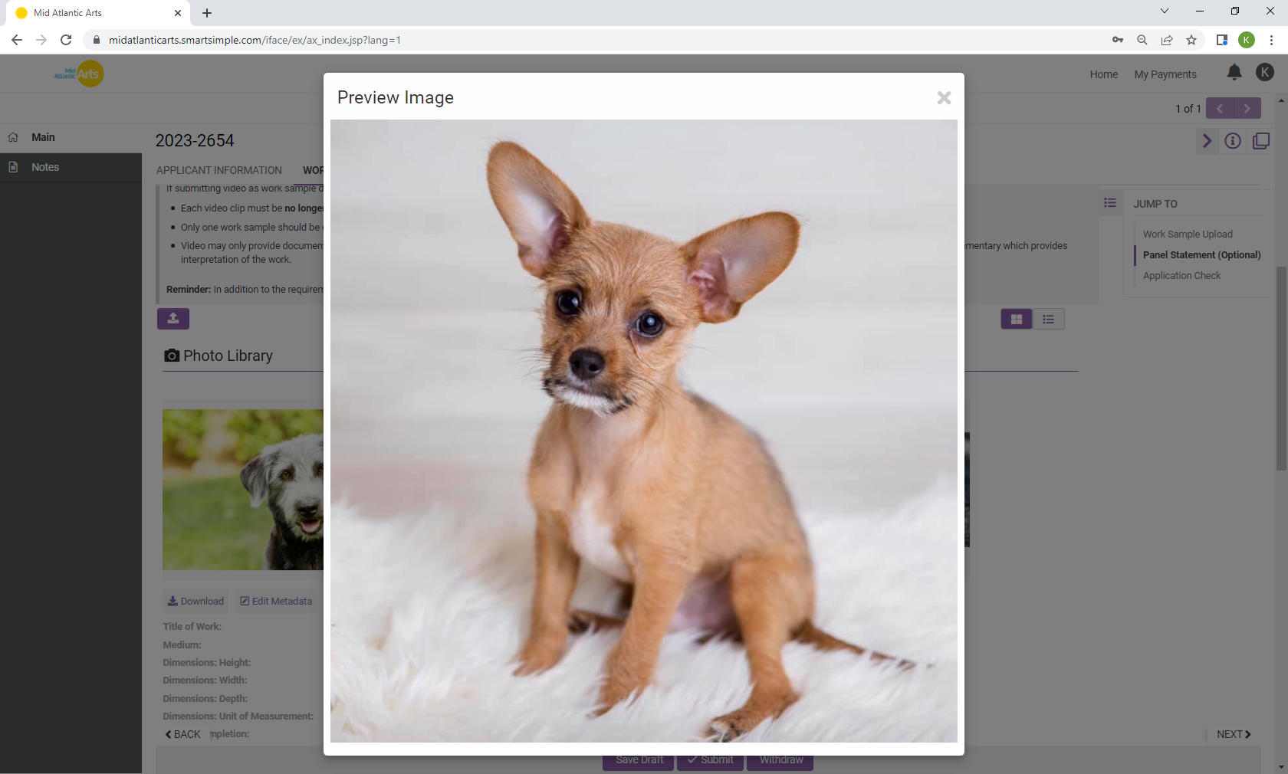

Is it a problem if my images are small?
Potentially, but the ability to view the work correctly is more important than a specific file or pixel size. Keep in mind that having a clear, detailed image will make it easier for the panelists to review your work. Submitting a very small image may make the details difficult to see. If a larger image is not available, you may want to consider also submitting a detail shot if there is a specific element of the work that you would like to highlight. Applicants in some categories may also have the option to submit video documentation of their work (please refer to the program rules & instructions for details).

I notice that the rules & instructions say I can’t have a signature in the image but I sign all my works. What should I do?
Because complete anonymity is a cornerstone of the Individual Artist Fellowships, applicants will be required to remove or cover the signatures in their work. Below are some suggested options for signature removal:

- Use Photoshop or photo editing software to obscure the signature digitally. You may choose to blend the signature into the work or simply block it out. As long as it is not possible to identify the artist, either option is acceptable.
- Manually cover the signature when photographing the work.
- Crop the signature out of the photo, although this is the least preferred method as it may compromise the composition and presentation of the work.

Can Mid Atlantic Arts help me remove the signatures?
Unfortunately, Mid Atlantic Arts staff are unable to assist with any editing that can impact the final appearance of the work sample.

Is it OK to use a composite image?
A composite image is when multiple images are combined into a single image file, generally to show multiple perspectives or details of a single work. Based on the feedback we’ve received from panelists, we generally discourage using composite images since including more than one image in a single upload often makes it too small to review properly.

An example of a composite image is below, along with Mid Atlantic Arts’ recommendations for submission of those individual images (Image Source: Rodin Museum):

Composite Image
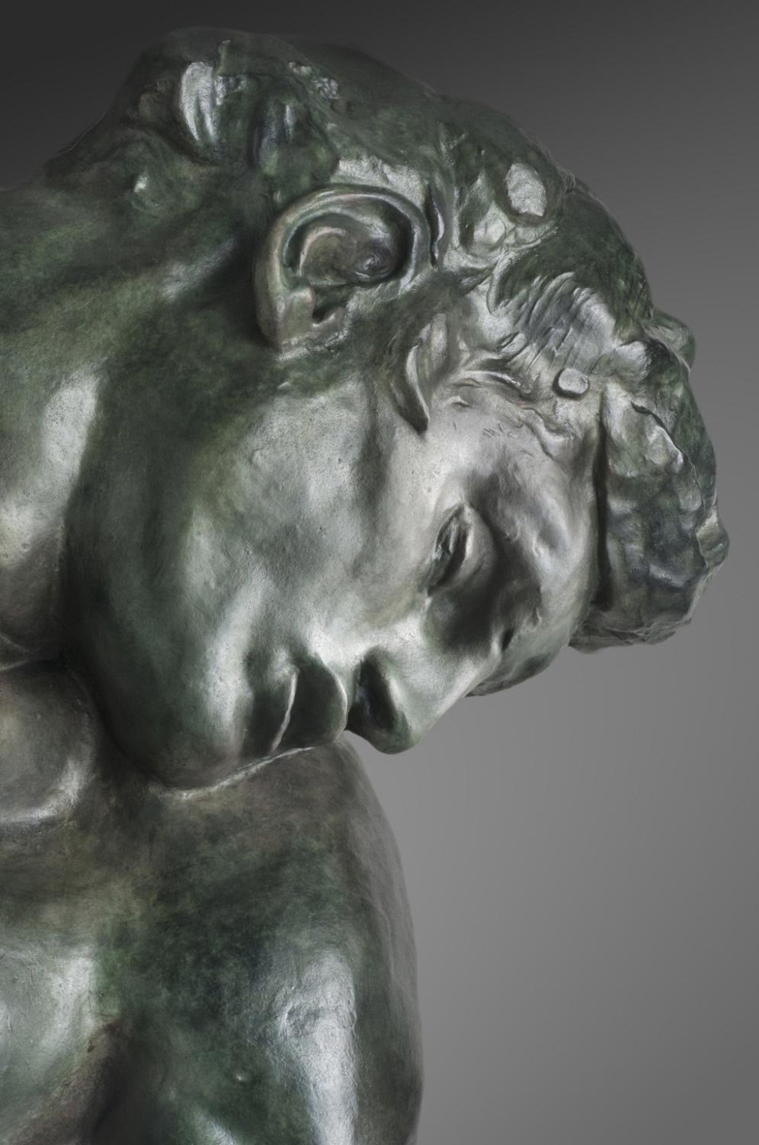
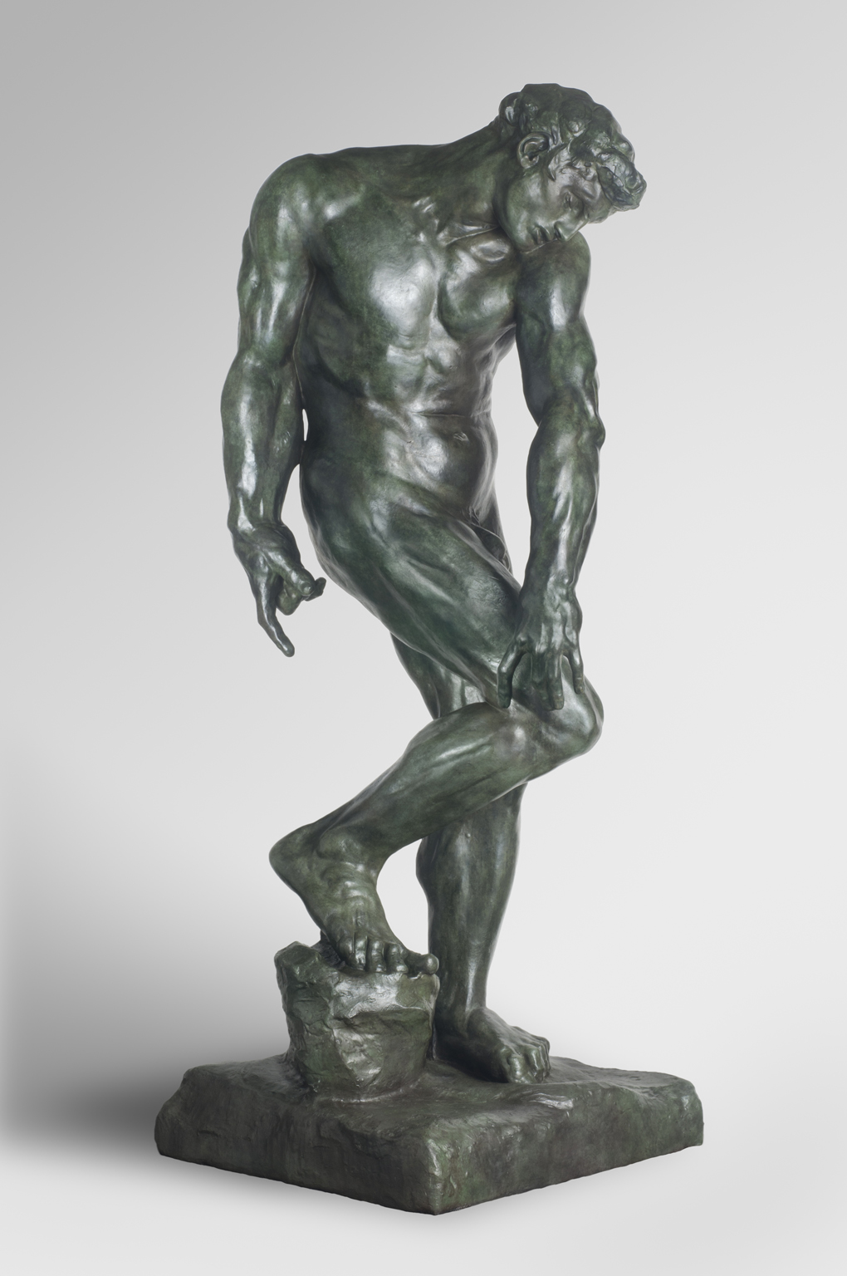

We recommend submitting these images as separate uploads in the online application as follows:

Primary Image Detail Shot

The rules & instructions specify that I should not submit more than six examples of my work. What if a single work contains multiple components?
If all components of a work are meant to be viewed together as one piece (a diptych, for example) it would be considered a single work sample for the purposes of this application.

This is distinct from a series of individual works that are stylistically or thematically connected, but which can be viewed independently without significant loss of meaning. You may submit multiple works from a series but they would be considered individual work samples.

It is also important to consider that works comprised of multiple components may be more difficult to adequately capture in a single image. Based on panelist feedback, Mid Atlantic Arts recommends providing an “overview” image which, to the greatest extent possible, captures all components of the work in one shot. This helps provide the panelists with a look at the full work and a sense of how it would be received. Depending on the guideline requirements for your category, you may also have the option to submit video documentation of your work.

If it is difficult to discern detail, Mid Atlantic Arts also recommends submitting one or more detail shots of the same work as separate image uploads. The Panel Statement section in the online application also provides an opportunity for applicants to add visual description of the work, if they feel it is necessary or helpful.

Three examples of work that could be submitted as one work sample are included below:

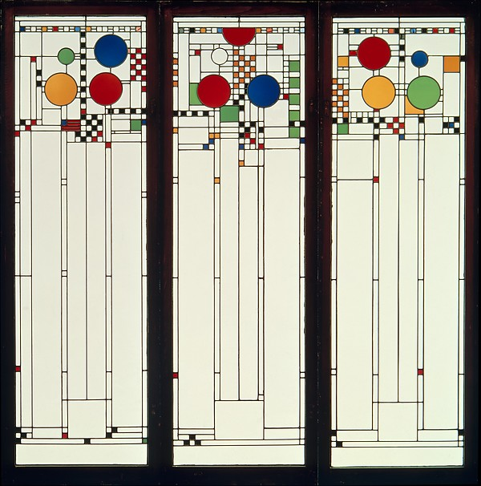
Source: Metropolitan Museum of Art

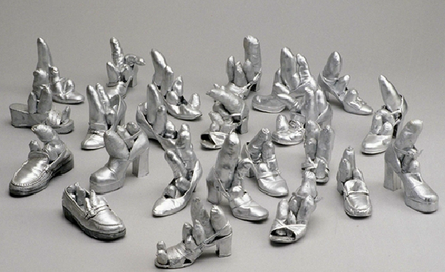
Source: Detroit Institute of Arts

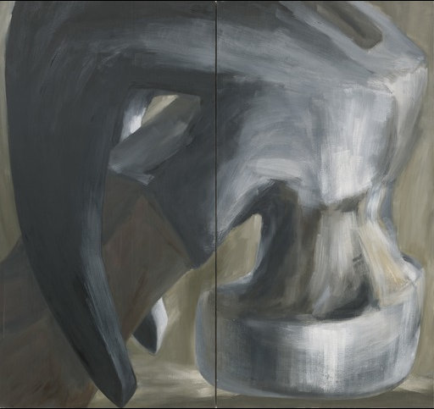
Source: Museum of Modern Art

VIDEO FILES

What are the file properties and how can I see if my files contain identifying information?
The file properties show information about a file that is stored within the file itself. This includes basic information about the file such as the file type, size, and length. However, information about the artist which may reveal the identity of the applicant can also be stored in the file properties. This can include anything from the name of the artist to information about the directors, genres, a playlist or album to which the file belongs, etc. Some media players will search for and display this type of information when playing back a file which endangers the anonymity of the application during the review process.

To check the file properties and see if your file contains identifying information, please follow these instructions:

Windows: Browse to the location where the file is saved. Right click the file then select “Properties.” Information about the file will be displayed here.
Mac: Browse to the location where the file is saved. Click “Control” + your file, then select “Get Info.” A window will pop up displaying the file properties.

Review this information carefully. Do not include any details about the work sample that isn’t provided in the online application. Be sure to remove any production details.

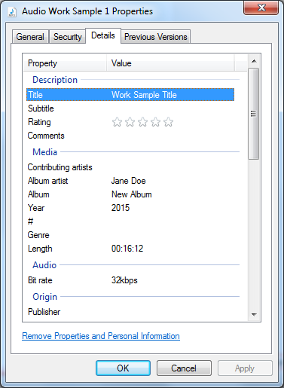
In this example, you can see that the file properties include identifying information, specifically
the artist and album name.

My audio or video file includes identifying information in the file properties. How do I remove it?
Both Windows and Mac users can delete optional file properties by clicking on each display property field and manually removing the information. Alternatively, Windows users can also delete metadata by clicking “Remove Properties and Personal Information.”

My file is too big. Can Mid Atlantic Arts help me compress or reduce the size of my file?
Unfortunately, Mid Atlantic Arts staff are unable to assist with editing or compressing video work samples as there are a number of different variables that can impact the final presentation quality of the work sample.

PDF FILES

How do I convert a file to PDF?
Most word processing programs will have a “Save as” function which allows users to convert their documents directly to PDF. Open the document you would like to convert, click “Save as” then select PDF as the “Save as Type” below the file name.

If your word processing program doesn’t have this function and you don’t wish to download Adobe Acrobat, the following websites are free and do not require software download:
https://www.freepdfconvert.com/
https://online2pdf.com/ (Allows users to combine multiple documents into one PDF file)

