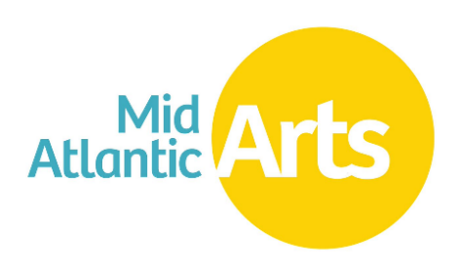
Performing Arts Global Exchange

Program Guidelines 2026-2027

PRESENTER BOOKING DEADLINE; OFFER LETTERS DUE TO AGENTS

March 23, 2026
TOURING PERIOD
July 1, 2026 – December 31, 2027

GRANT NOTIFICATIONS

By June 30, 2026

ACCESSIBILITY
This publication is available in .PDF format and as an accessible Word file at https://www.midatlanticarts.org/. For additional accessibility requests, contact Andrew Alness Olson, Program Director, International at andrew@midatlanticarts.org.

ABOUT THE PROGRAM
Performing Arts Global Exchange (“PAGE”) is a nationwide grant program designed to increase availability of international performing arts programming throughout the United States and to promote a greater understanding of other cultures through the performing arts. PAGE provides fee support grants to nonprofit presenters located anywhere in the United States and its territories that contract performing artists from the annually curated PAGE roster. Artists on the roster reside in a focus region, selected for its rich diversity of artists. The 2026 touring roster features ensembles and artists based in Portugal and Spain.
All funded engagements are required to include a public performance and a community engagement activity that provides audiences direct interaction with the visiting artists. An emphasis is placed on funding engagements in underserved communities that have little access to this type of artistic work.
PAGE is a program of Mid Atlantic Arts with the generous support of the National Endowment for the Arts (“Endowment”).

HOW IT WORKS
- Nomination Process: An open call for artists from the chosen region to self-nominate was opened in October 2025. Curators from the region or with a strong connection to the region were also selected. Curators provided additional artist nominations, and reviewed all submissions, making recommendations on which artists should proceed to the next round of the selection process. Feedback on a shortened list of potential roster artists was gathered via an online survey of U.S. presenters in November 2025. Mid Atlantic Arts determines the final roster giving consideration to presenter feedback, curator review, and program objectives.
- The Artist Roster & Focus Region: The roster includes exemplary ensembles and artists exclusively based in a selected region of the world. This year the focus is Portugal and Spain. Focus regions change annually or biennially. To review the artist roster and learn more about the program visit our website.
- Booking Period: Eligible presenters must contact PAGE roster artists’ agents to contract an engagement scheduled between July 1, 2026 and December 31, 2027. Firm, written offers must be received and accepted by roster artist agents on or before March 23, 2026.
- Grant Awards: Fee subsidy grants will vary and may support up to 50% of the inclusive fee negotiated between the agent and the presenter. Grants generally range between $1,500 - $8,000.
- How to Receive a Grant Award:
  - Interested presenters should contact the roster artist’s booking agent directly to negotiate terms of the engagement, including artist-involved community engagement activities and any potential fee subsidy. Visit midatlanticarts.org to view the artist roster.
  - Offer letters must include
    - the presenter’s name and contact information,
    - public performance date(s)
    - community engagement activity date(s) and details of planned engagement
    - negotiated artist fee
    - recommended grant support amount, as negotiated with the artist’s agent
  - After the booking period ends on March 23, 2026, agents provide Mid Atlantic Arts with offer letters and Mid Atlantic Arts contacts eligible presenters directly with instructions to receive fee subsidies.
    - Presenters interested in receiving subsidy must then complete a brief online form in April 2026 with details about their organization and the engagement, including details of the planned artist-involved community engagement.
  - We encourage the participation of presenters from a variety of eligible organizations including: organizations that serve populations that are underserved, such as those whose opportunities to experience the arts are limited by ethnicity, economics, geography, or disability; organizations with small and medium-sized budgets; organizations from rural to urban communities; and organizations that may be receiving funding from Mid Atlantic Arts in partnership with the National Endowment for the Arts for the first time.
- Determination of Grant Award Amounts:
  - Presenters reaching communities underserved by the arts will be given priority consideration for support.
  - Priority will also be given to presenters reaching communities that otherwise would have little access to live performance experiences with artists from abroad, such as those outside of large urban centers.
  - All eligible presenters that contract an eligible engagement, regardless of priority status, will be eligible for a fee subsidy grant award.
  - Presenters will be selected on the artistic excellence and merit of their proposed activity engagement as well as compelling outreach to their community.

PRESENTER ELIGIBILITY
In order to receive PAGE fee support grants a presenting organization must:
- Be based anywhere in the United States and its territories (American Samoa, Guam, Northern Marianas Islands, Puerto Rico, and U.S. Virgin Islands).
- Be a 501(c)(3) nonprofit organization or a unit of state or local government. Units of state or local government must provide a document on official letterhead to confirm status as a government entity. Fiscal sponsorship is not permitted for this program.
- Be in good standing with Mid Atlantic Arts, with no overdue or outstanding required reports and/or grant documents.
- For this program, a presenter is defined as an organization that regularly schedules and engages professional artists to perform before general audiences in its community and manages the related performance logistics as an ongoing and significant component of their organization’s activity.

ENGAGEMENT REQUIREMENTS
In order to receive PAGE fee support grants a presenting organization must:
- Enter into a contract with a PAGE roster artist for at least one public performance and at least one community engagement activity that builds appreciation for the performance or art form and provides the public with opportunities for direct interaction with the visiting artists. Community engagement activities may include, but are not limited to, master classes, lecture-demonstrations, workshops, and pre- or post-performance discussions. The activity offered must involve the featured artist(s). Presenters must discuss the community engagement activity and the artist’s involvement with the artist’s booking agent and include these activities in their negotiations. Presenters must provide details on community engagement plans before being confirmed for a grant award.

GRANT AWARD DETAILS
- An eligible presenter can receive up to three Performing Arts Global Exchange grant awards per year provided each engagement meets program guidelines. Each engagement is considered a separate award and documentation will be required for each.
- Fee support grants are based on demand and are available only as long as limited funds will allow. Presenters are encouraged to secure artist engagements as soon as possible.
- Fee subsidy is not guaranteed until confirmed by Mid Atlantic Arts.
- Funding awarded by Mid Atlantic Arts is restricted to the specific, direct costs of the project, as detailed in the grant awards section above, and may not be used for indirect costs.
- Grants must be matched on a 1:1 basis. The match may not include Federal funds and the required match may not be used to match other Federal funds whether they are received directly from a Federal agency or indirectly, such as through a state agency or other entity.
- Any air travel directly paid by the presenter in whole or in part with this grant or the match must follow the provisions of the Fly America Act. Any air travel must be done on a U.S. flag air carrier which can include service provided under a code share agreement with a foreign air carrier when the ticket, or documentation for an electronic ticket, identifies the U.S. flag air carrier’s designator code and flight number. Exceptions to the Fly America Act are outlined in the Grant Award Agreement.
- On occasion, additional grant funds may become available during the Booking Period. If you have interest in a Performing Arts Global Exchange roster artist but were unable to secure a date by the booking deadline, please contact the roster artist booking contact to express interest.

GRANT AWARD TIMELINE, NOTIFICATION, PAYMENT, AND FINAL REPORT
- Firm, written offers must be received and accepted by roster artist agents on or before March 23, 2026.
- Presenters will be notified of fee support recommendations and will be required to fill out a short online form with engagement and community engagement activity details in April 2026.
- Presenters will be notified of official fee support grant approval by the end of June 2026.
- If awarded, 100% of the presenter grant will be released at the beginning of the grant period (30 days prior to the first engagement activity) provided that the following items have been completed by the grant recipient:
  - Review and execution of a grant award agreement
  - Upload of a copy of the counter-signed contract with the proposed artist in the Mid Atlantic Arts portal no later than 30 days prior to the first engagement activity
- Final Report: A final report for a funded project is to be completed and is due no later than 30 days after the conclusion of the final engagement activity. The final report, made available in the Mid Atlantic Arts portal at the time the grant is awarded, requires a brief description of the completed project along with an accounting of expenditures for the funded activities. Final report instructions are provided as part of the grant award documents. The final 10% of the grant is paid once a complete and satisfactory final report is received from the grant recipient and approved.

CONTACT US
Andrew Alness Olson, Program Director, International at andrew@midatlanticarts.org.
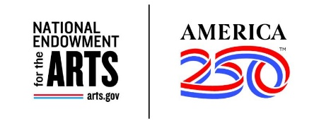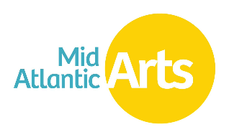
Performing Arts Global Exchange is made possible through the generous support of the National Endowment for the Arts.

