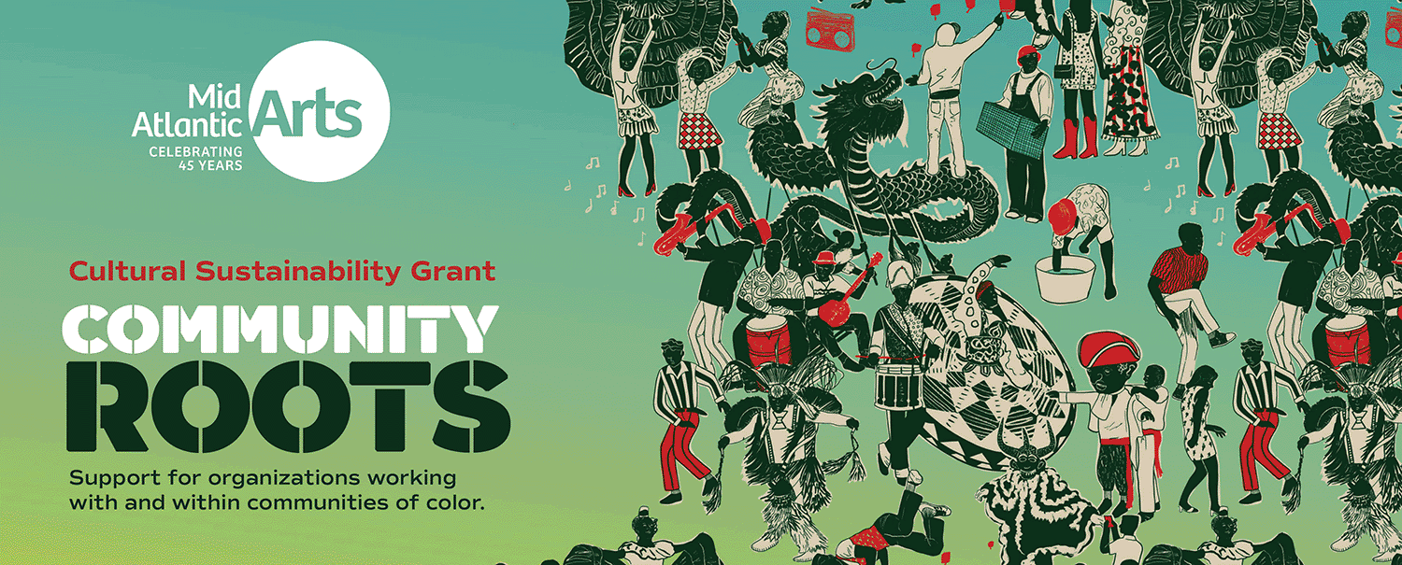

Cultural Sustainability: Community Roots

Program Guidelines 2024-2025

**Informational Webinar:** [**October 31, 2024, 3:00pm – 4:00pm**](https://us02web.zoom.us/webinar/register/WN_MxUYGdBGSWur5Xx3IjfCBg)

**Application Opens: November 12, 2024**

**Drop-In Sessions:**

**English: November 13, 2024, between 3:00pm – 5:00pm**

**Spanish: November 14, 2024, between 3:00pm – 5:00pm**

**Application Closes: January 6, 2025, 11:59pm EST**

**Program Period: May 2025-June 2026**

# ABOUT MID ATLANTIC ARTS

Mid Atlantic Arts nurtures and funds the creation and presentation of diverse artistic expressions and connects people to meaningful arts experiences within our region and beyond.

Founded in 1979, Mid Atlantic Arts supports artists, presenters, and organizations through grants, programs, and partnerships. Working with state arts councils and the National Endowment for the Arts (NEA), it combines public and private funding to promote diverse artistic expressions and connect people to meaningful arts experiences in the region and beyond.

# ACCESSIBILITY

Guidelines are available in English and Spanish in both PDF and accessible Word formats [here](https://www.midatlanticarts.org/opportunity/cultural-sustainability/).

For accommodation or language translations, contact: [culturalsustainability@midatlanticarts.org](mailto:culturalsustainability@midatlanticarts.org). Please make requests at least 5 business days before the application deadline to ensure proper assistance.

# WHAT IS CULTURAL SUSTAINABILITY?

Cultural Sustainability, with support from the Wallace Foundation, is an initiative that the six [U.S. regional arts organizations](https://usregionalarts.org/) (RAOs) have launched to support arts and culture in Black, Indigenous, and people of color (BIPOC) communities. The goal is to ensure that BIPOC arts organizations receive funding comparable to that of historically well-established organizations.

This program provides unrestricted operational funding to arts organizations founded by, with and for communities of color, allowing them to sustain and expand their practices, benefiting the communities they serve. It also supports cross-cultural arts experiences and fosters stronger collaboration between artists, communities, and the RAO’s.

The Cultural Sustainability Grant Program provides general operating support to arts and culture organizations serving BIPOC communities with budgets under $500,000 and at least three years of programming. Mid Atlantic Arts will select up to 20 grantees from its [10 states and territories](https://usregionalarts.org/):

* 10 selected organizations (one per state and territories) with operating expenses between $0-$249,999 will receive a general operating grant up to $46,000.
* 10 selected organizations (one per state and territories) with operating expenses between $250,000 - $499,999 will receive a general operating grant up to $66,000.

# CRITERIA TO RECEIVE A CULTURAL SUSTAINABILITY GRANT

To be eligible for this grant, your organization needs to meet the following criteria:

* **Budget:** Operating budget under $500,000 (excluding emergency funding like COVID relief, CARES Act, ARPA).
* **Experience:** At least three years of arts and cultural programming. These years don’t have to be consecutive or tied to your incorporation date.
* **Community Focus:** Your programming should show a strong commitment to supporting historically underserved communities of color.
* **Leadership:** Your leadership team must be closely connected to the communities they serve, whether artistically or administratively.
* **Mission:** Your arts organization's mission should prioritize working within and/or serving communities of color.
* Your organization is working to address systemic inequities through their practices.
* **Your organization must also be one of the following:** 
  + 501(c)(3) nonprofit
  + For-profit entity (LLC, S-corp, etc.)
  + Artist collective (either incorporated with a tax ID or with a fiscal sponsor from an established for-profit or non-profit entity that has a tax ID)
* **Not** have received [ArtsHERE](https://usregionalarts.org/artshere/) funding from your RAO

# HOW TO APPLY?

The grant application portal for Cultural Sustainability will open at 9am ET on Monday, November 12th.

Organizations must create a new login through SmartSimple. If you have already registered, you are not required to create a new login. Simply log into your account and go straight to ‘Step 2: Apply’. Email the Program Associate for Performing Arts and Creativity in Community, Sarah Theune at [sarah@midatlanticarts.org](mailto:sarah@midatlanticarts.org), if you have any questions about your account status.

## Step 1: Register (if applicable)

1. Register in our [SmartSimple grants portal](https://midatlanticarts.smartsimple.com/s_Login.jsp)
2. On the registration page, choose the type of organization that fits you.
   * "Registered Non-Profit Organization" if your organization is a registered 501(c)(3)
   * "U.S. State and Local Governments or Federally Recognized Tribal Governments" if your organization is a federally recognized tribal government, or
   * "Other Organization/Group" for all other types of entities
3. Enter your information and submit your registration.
4. Check your email for a login link and click it.
5. Create a new password and click submit.
6. Check your email for a verification code, copy it, and paste it in the box on the login page.
7. You’re now in the SmartSimple portal! Verify your profile by clicking on the letter symbol in the top right corner and selecting “Organization Profile” to confirm your registration information.

## Step 2: Apply

1. Go to the Home page and click on “Funding Opportunities.”
2. Select “Apply Now” for Cultural Sustainability.
3. Click “Save” to start your application.
4. Answer the questions and click “Submit” when you’re done. You can also save your progress by selecting “Save Draft” but remember to click “Submit” before the deadline.

## Required Materials for the Application: (This can be submitted as a text document or PDF)

* Proof of community engagement (e.g. letter of recommendation, a partnership letter, or a program description that details your mission, a letter of support from a notable artist or community leader. etc.).
* Evidence of operational budget (last three years) or evidence of expenses for the last three years.

## Work Samples: Work samples are optional but highly encouraged as they help reviewers understand your organization and its community connection.

Choose Wisely: Select two samples to submit, as reviewers will spend about 5 minutes on them.

Suggested Work Samples:

* A link to your organization's website or social media.
* A link or photo of a local news feature highlighting your organization.
* A photo or video from a successful community event (e.g., workshop, performance).
* Audio or video excerpts of your organization’s work.

Work Sample Specifications:

**Audio/Video:** The maximum length is 3 minutes; if the video is longer, specify which 3-minute section to view. Upload in MP4 format or provide a link to platforms like YouTube, Vimeo, SoundCloud, or Spotify, including a password if needed.

**Photos:** Recommended formats: JPEG/JPG or PNG.

**Documents:** Length: 1 page per document. Recommended format: PDF.

# HOW CAN I USE CULTURAL SUSTAINABILITY FUNDING?

Cultural Sustainability grants for organizations and LLCs are unrestricted, meaning you can use them to strengthen and sustain your work without needing to designate funds for a specific project. However, the funds should directly support your organization's activities.

These funds can be used for various purposes, including:

* Building capacity
* Operational support
* Expanding programs
* Upgrading technology
* Engaging with the community
* Covering rent and utilities

For businesses and LLCs, there may be specific requirements for using the funds, so feel free to reach out with any questions.

# GRANT PAYMENTS, TAXES, AND REQUIREMENTS

## AWARDS

Mid Atlantic Arts plans to disburse a majority of the grant at the time of award. Grantees will also have the option of receiving their award payment in installments throughout the grant period.

This includes:

* Unrestricted general operating funding
* Operational support

If awarded, you will receive your first payment within 60 days of when Mid Atlantic Arts has received and approved all necessary award documents.

* Cultural Sustainability funding is considered taxable income unless your organization is tax-exempt. All grantees are responsible for reporting grant funds to the IRS. For-profit entities that receive these grants must pay any related taxes. Mid Atlantic Arts offers tax support resources and can assist you with your needs.
* Selected grantees are expected to lead a virtual workshop during the program's one-year duration, focusing on community engagement, cultural preservation, inclusivity, or social advocacy. Grantees will also be invited to join virtual peer networking sessions and quarterly check-ins with Mid Atlantic staff.
* If you receive funding, you must complete a grantee impact survey and participate in a recorded interview with a U.S. RAO representative during the award year (May 2025 – June 2026). Grantees must submit a final report by July 31, 2026, after the grant period ends. You can submit the report in SmartSimple.

# PANEL REVIEW PROCESS

After you submit your application, you will receive an email confirmation to confirm receipt of your information. Mid Atlantic Arts staff will contact you if we have any questions.

Applications will be reviewed by a panel consisting of arts and cultural leaders and BIPOC artists and community organizers.

# WEBINARS AND DROP-IN SESSIONS

**Webinar:**

October 31, 2024, at 3:00pm ET

**Drop-In Sessions:**

November 13, 2024, between 3:00pm – 5:00pm ET

November 14, 2024, between 10:00am – 12:00pm ET

## Deadline:

* **Application closes: Wednesday, January 6, 2025 – 11:59pm EST**

## Final Grantee Report

Grantees must complete a final grantee report by July 31, 2026, after the grant period closes. The grantee report can be found in SmartSimple.

# CONTACT US

Contact Sarah Branch, Program Director, Creativity in Community at [sbranch@midatlanticarts.org,](mailto:sbranch@midatlanticarts.org) or Sarah Theune, Program Associate, Performing Arts & Creativity in Community at [sarah@midatlanticarts.org](mailto:sarah@midatlanticarts.org) or call 410-539-6656 x120

**The Cultural Sustainability application, including narrative questions and work sample requirements, can be previewed and downloaded in Microsoft Word and PDF formats at this link:** [**https://www.midatlanticarts.org/opportunity/cultural-sustainability/**](https://www.midatlanticarts.org/opportunity/cultural-sustainability/)

For questions about language accessibility, please contact [culturalsustainability@midatlanticarts.org](mailto:walkingtogether@midatlanticarts.org).